/\*Assignments based on File Handling in Java\*/

Program1-

import java.io.FileWriter;

import java.io.IOException;

public class CreateFile

{

public static void main(String[] args) throws IOException

{

String str = "File Handling in Java using "+

" FileWriter and FileReader";

FileWriter fw=new FileWriter("output.txt");

for (int i = 0; i < str.length(); i++)

fw.write(str.charAt(i));

System.out.println("Writing successful");

//close the file

fw.close();

}

}

Output-

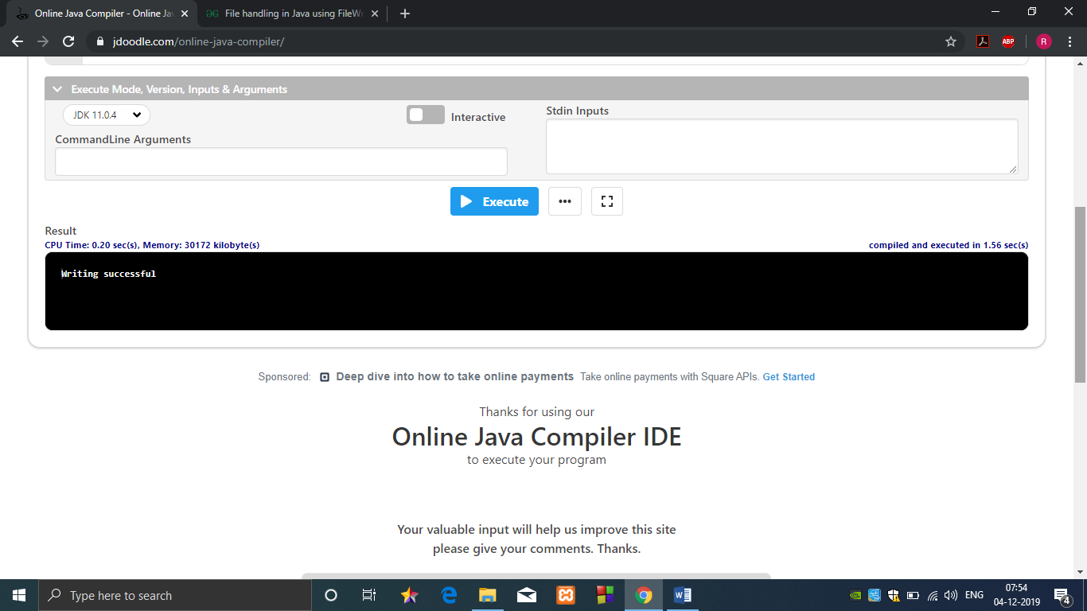

Program 2-

import java.io.FileNotFoundException;

import java.io.FileReader;

import java.io.IOException;

public class ReadFile

{

public static void main(String[] args) throws IOException

{

// variable declaration

int ch;

// check if File exists or not

FileReader fr=null;

try

{

fr = new FileReader("text");

}

catch (FileNotFoundException fe)

{

System.out.println("File not found");

}

// read from FileReader till the end of file

while ((ch=fr.read())!=-1)

System.out.print((char)ch);

// close the file

fr.close();

}

}

Output-

